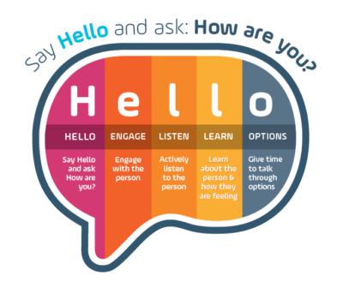

A number of Libraries around the country are kindly supporting the Hello, How Are You? campaign 2023 by acting as a collection hub for conversation cards and bookmarks. Drop into one of the locations listed below to pick up your free resources.
Cork City Library
Dundalk Library HQ Store
North Clondalkin Library
Libraries Events Section, Cabra Bibliographic Centre
Laois County Library HQ
Lucan Library
Swords Library
Tullamore Library
Ballywaltrim Library
Baltinglass Library
Dunlavin Library
Rathdrum Library
Dungarvan Library
Central Library Waterford
Greystones Library
Bandon Library

